**Smart Water System**

**Introduction:**

A smart water system is a cutting-edge approach to water management that leverages advanced technologies to enhance the efficiency, sustainability, and reliability of water supply and distribution. These systems are becoming increasingly important in the face of growing water scarcity and the need to modernize aging infrastructure. In this comprehensive discussion, we will delve into the key components, benefits, and challenges of smart water systems in approximately

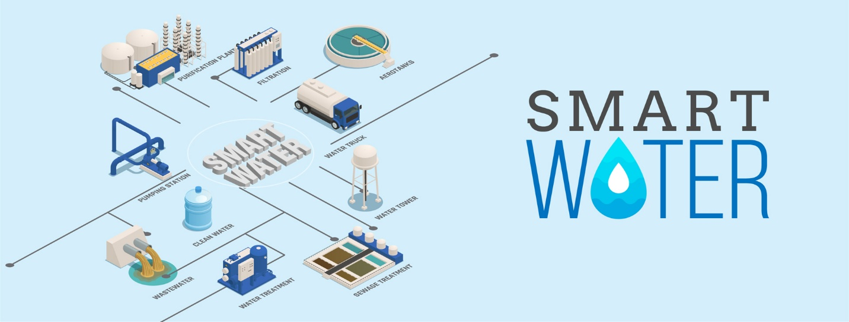

**Components of smart water system:**

A smart water system comprises various interconnected components, each serving a specific purpose in optimizing water management:

* Sensors and Data Collection: The foundation of any smart water system is an array of sensors deployed throughout the water infrastructure. These sensors monitor critical parameters such as water flow, pressure, quality, temperature, and even weather conditions. Data collected from these sensors is transmitted to a central hub or cloud-based platform.
* Data Analytics: Once the data is collected, it undergoes extensive analysis. Advanced analytics and machine learning algorithms process this data to identify patterns, anomalies, and trends. This information is invaluable for making informed decisions about water usage and distribution.
* Consumer Engagement: Many smart water systems offer user-friendly interfaces, such as mobile apps or web portals. These interfaces allow consumers to access real-time information about their water usage, billing, and conservation tips. Empowering consumers with this information encourages water-saving behaviors.
* Pressure Optimization: Maintaining consistent water pressure is essential for an efficient distribution network. Smart systems can adjust pressure in realtime, reducing the risk of pipe bursts and optimizing energy usage in pumping stations.
* Water Quality Control: Continuous monitoring of water quality parameters ensures that the water supplied meets safety standards. Any deviations from these standards can trigger alerts, leading to immediate corrective actions.
* Sustainability: Ultimately, smart water systems contribute to the sustainable management of water resources. They reduce water wastage, lower operational costs, and minimize the environmental impact of water distribution.

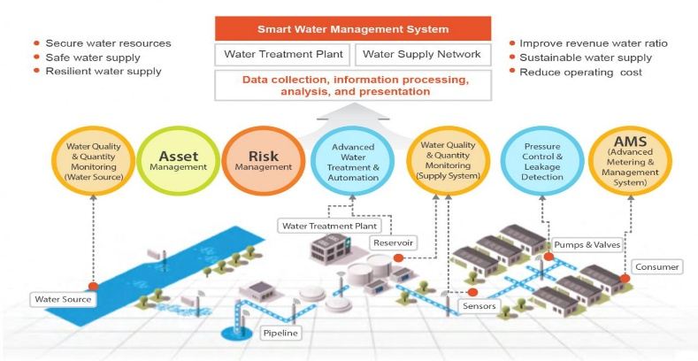

**Benefits of Smart Water Systems:**

Implementing a smart water system yields a wide range of benefits for both water utilities and consumers:

* Water Conservation: By detecting and addressing leaks and providing realtime usage information to consumers, smart water systems promote water conservation. Reduced water wastage helps preserve precious water resources.
* Cost Savings: The early detection of leaks and predictive maintenance capabilities lead to significant cost savings for water utilities. Avoiding infrastructure damage and optimizing energy usage reduces operational expenses.
* Improved Service Reliability: Smart water systems enhance the reliability of water supply. Remote control and real-time adjustments minimize service interruptions and ensure consistent water pressure and quality.

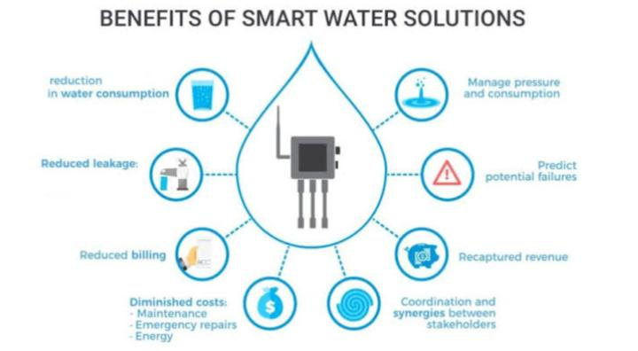

* Enhanced Customer Engagement: Consumers benefit from increased transparency and control over their water usage and bills. This engagement encourages water-saving behaviors and fosters a sense of environmental responsibility.

**Challenges and Considerations:**

While smart water systems offer numerous advantages, they also present challenges and considerations:

* Initial Investment: Implementing a smart water system requires a substantial upfront investment in sensors, data infrastructure, and software. Securing funding can be a barrier for smaller utilities.
* Data Security: Handling large amounts of sensitive data requires robust security measures to protect against cyber threats. Ensuring data privacy and integrity is paramount.
* Regulatory Compliance: Meeting regulatory requirements, particularly in terms of water quality and data handling, is essential. Smart water systems must adhere to these standards.

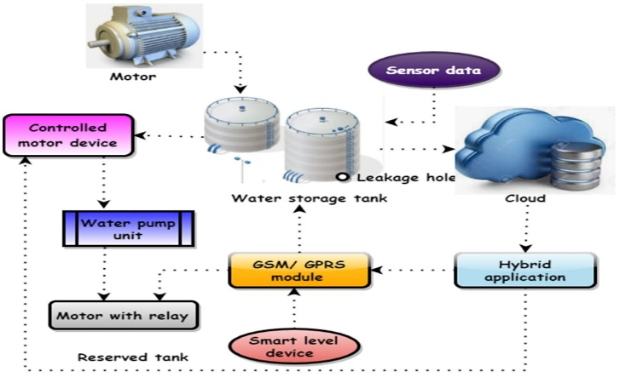

**Conclusion:**

In conclusion, a smart water system represents a transformative approach to water management, leveraging technology to optimize distribution, reduce wastage, and enhance sustainability. While challenges exist, the benefits in terms of water conservation, cost savings, and improved service reliability make smart water systems a crucial investment in addressing the pressing water-related challenges of our time. These systems not only empower utilities but also engage consumers in the responsible use of this precious resource.